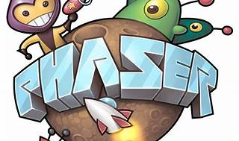

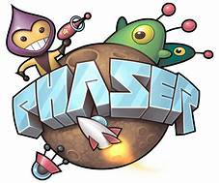

Explore

Certainly! In a nutshell, **Phaser** is a popular **JavaScript framework** specifically designed for **web-based game development**. [It allows developers to create games that can be played directly in a web browser using technologies like HTML, CSS, and JavaScript1](https://gamedevacademy.org/what-is-phaser/).

Here are **five free reference links** where you can learn more about Phaser:

1. [**Understanding Chorus, Flangers, and Phasers in Audio Production**: This article explains the differences between chorus, flangers, and phasers, how they work, and how to use them in audio mixing](https://gamedevacademy.org/what-is-phaser/)[2](https://www.izotope.com/en/learn/understanding-chorus-flangers-and-phasers-in-audio-production.html).
2. [**What Is Phaser? - JavaScript Game Dev**: Dive into Phaser’s versatility and robustness for game development on the web1](https://gamedevacademy.org/what-is-phaser/).
3. [**Getting Started with Phaser 3**: Learn the basics of Phaser, an HTML5 game framework designed for web browsers](https://gamedevacademy.org/what-is-phaser/)[3](https://phaser.io/tutorials/getting-started-phaser3).
4. [**Phaser vs. Flanger: What They Are and How They Sound**: Explore how phasers work and how they can be applied in analog and digital contexts](https://gamedevacademy.org/what-is-phaser/)[4](https://splice.com/blog/phaser-vs-flanger/).
5. [**Bonus**: Try these effects yourself with a free trial of **iZotope’s Music Production Suite Pro membership**, which includes Nectar Pro and VocalSynth Pro—two plug-ins that incorporate effects like chorus, flangers, and phasers](https://gamedevacademy.org/what-is-phaser/)[2](https://www.izotope.com/en/learn/understanding-chorus-flangers-and-phasers-in-audio-production.html).

Happy learning! 🚀🎮